2018 EPIK Video Clip Contest
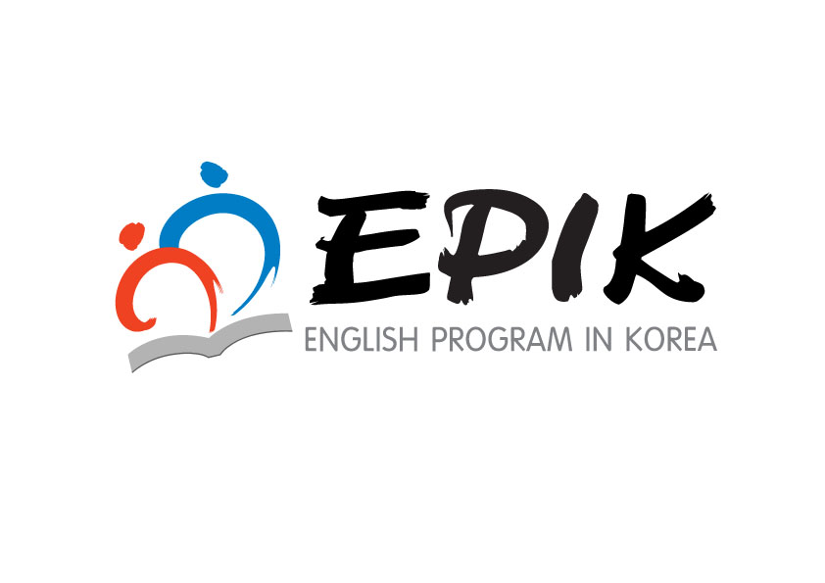

EPIK is holding two video clip contests. The “Co-teaching Video Contest” aims
to showcase the best co-teaching models in order to improve English Education.
The “EPIK Life Video Contest” seeks to improve cultural understanding and to help create
a smooth transition to life in Korea for current and future EPIK teachers.
We look forward to your interest and participation in these special events.

Eligibility and Award Outline

 | Co-teaching  Video Clip | EPIK Life  Video Clip
Eligible  Applicants | Korean Teacher &  Guest English Teacher | Guest English Teacher  (GET)
Topic | Co-teaching Class | School life, daily life in Korea, cultural experiences, etc.
Awards | ￦1,000,000×1 (Team) | ￦500,000×1 (Individual)
 | ￦800,000×1 (Team) | ￦400,000×1 (Individual)
 | ￦600,000×1 (Team) | ￦300,000×1 (Individual)
 | ￦400,000×1 (Team) | ￦200,000×1 (Individual)

※ Notes
- The number of winners may be adjusted according to the quality of work submitted.
- Winners of the Co-teaching Video Clip will be awarded a prize which is to be shared evenly between both the GET and Korean co-teacher.
- The first-place winners of previous contests and awards cannot participate in the same category.

Contest Schedule
○ Submission Period: Monday, November 5th ~ Friday, November 16th
○ Announcement of Winners: Wednesday, December 5th
The result will be posted in the “What’s New” section of the EPIK website.
○ EPIK Website Video Upload: Monday, December 17th ~
○ Presentation of Awards: Thursday, December 6th
○ Transfer of Prize Money: Thursday, December 6th ~ Wednesday, December 12th
※ Schedule is subject to change.

Evaluation Criteria

○ Co-teaching Video Clip

 | Criteria | Points
Content | - Is the lesson designed with effective learning activities to assist in achieving the lesson’s goals?  - Do the teachers effectively encourage student participation in the activities?  - Was the lesson effective in increasing the communication competency of the students?  - Does the model class clearly define the roles of the co-teacher and GET?  - Did the teachers provide appropriate and useful teaching materials and use them effectively throughout the lesson? | 50
Usefulness | - Can the model class easily be adapted into a regular classroom?  -Can the entry be used for EPIK training and promotional materials?  - Does the entry support a positive image of EPIK? | 30
Construction and Visual Appeal | - Is each portion of the demonstration edited in a way to help improve understanding of the whole lesson?  - Does the video effectively demonstrate cooperation between teachers and students?  - Is the video clip of good quality and viewer friendly?  - Does the video entertain viewers? | 20

○ EPIK Life Video Clip

 | Criteria | Points
Content | - Does the video contain a variety of activities from all aspects of the GET’s life in Korea? Examples include: school life (teaching  in the classroom, relationship between teachers & students, participation in school events, etc.), cultural experiences, and hobbies in Korea (EPIK Life).  - Does the video provide appropriate and useful information to viewers?  - Does the video entertain viewers? | 50
Usefulness | - Can the entry be used for EPIK training and promotional materials?  - Does the entry support a positive image of EPIK? | 20
Construction and Visual Appeal | - Is the video clip well-organized into categories?  - Are the ideas of the entry fresh and creative?  - Is the video clip of good quality and viewer-friendly? | 30

Requirements

` | Requirement Details
Co-teaching  Video Clip | - Application  Attachment 1-1  Attachment 1-2  - 3 copies of Lesson Plan  - 3 copies of “Explanation of Co-teaching”:  KT in Korean & GET in English (2 pages per teacher)  - A DVD or USB of Co-teaching Video Clip  ·Type: Movie clip or flash file (WMV, SWF, AVI, MP4)  ·Size: Maximum 2 Giga Byte  ·Running time: 10 minutes  ※ Please edit your class (40~50 minutes) into a 10 minute video clip in a way that best helps viewers understand your lesson.  ※ Submitted DVDs and USBs will not be returned.  ※ Previous award winning video clips can be found at www.epik.kr→ Co-Teaching Videos  “Explanation of Co-teaching” can be found at Teachers’ Resources→EPIK Teachers’ Essays  /Korean Teachers’ Essays (No. 42)
EPIK Life  Video Clip | - Application  Attachment 2-2  Attachment 2-1  - 3 copies of “ Introduction of Video Clip”  - A DVD or USB of EPIK Life Video Clip  ·Type: Movie clip or flash file (WMV, SWF, AVI, MP4)  ※ Please submit only video clips and not static photo slide shows.  ※ Submitted DVDs and USBs will not be returned.  ·Size: Maximum 1 Giga Byte  ·Running time: 5 minutes

How to Apply

○ Submission Period: Monday, November 5th ~ Friday, November 16th

○ Where to Send Submissions :
▪ Send by mail to: Kwon, KiJung, EPIK Office, Room 802
191, Jeongjail-ro, Bundang-gu, Seongnam-si, Gyeonggi-do (zip code: 13557)
▪ Contact: Kwon, KiJung (02-3668-1427, coolzalove1@korea.kr)

IMPORTANT NOTICE
○ The application process requires official document work (Principal’s recommendation & Official Seal, etc.) from your school. You must let your co-teacher, vice principal and principal know your intentions to take part in the contest and clarify what the prize is. We do not accept applicants who do not follow the official application procedures.
○ All movie clips submitted to us will not be returned.
○ If your entry is selected as one of the winners, EPIK will own its copyright and may revise and use it freely for future promotions, orientations and/or training.
○ The winners may have a chance to become lecturers or presenters at an official EPIK orientation.
○ Plagiarism is not allowed. If it is found out at any point, even after receiving an award, that the work submitted was not your own, the award will be revoked and the prize money must be returned to EPIK. The applicant will bear all responsibility for their actions.

Application Form for 2018 Co-teaching Video Clip Contest
Attachment 1-1
접수 번호  (EPIK 기재용) | 2018 EPIK 협력수업 동영상 공모 신청서  Application for 2018 EPIK Co-teaching Video Clip Contest
인적사항  Applicant Information | Name |  | Cell Phone | E-mail
 | (KT)
 | (GET)
학교 및 대상학년 | 학교 (지도대상: 학년)
단원명
근무처 | 우편번호
 | 주소
 | 전화번호 | ( )-( )-( )
입금  계좌 정보  Account Information | Account holder’s Name |  | Bank Name | Account Number
 | (KT)
 | (GET)

본인은 본인의 협력수업 동영상 및 관련 자료가 EPIK 사업과
교육적인 목적으로만 활용되는 것에 동의합니다.
I hereby give permission to use my video clip and other materials
for educational purposes and EPIK related business only.

제출자: 한국인 교사 성명 (인)
Guest English Teacher's Name
Signature

위 교사들은 평상시에도 영어 협력수업을 잘하고 있으며, 본교의 영어교육발전을 위해 늘 헌신하는바, 국립국제교육원 동영상 공모전에 적극 추천합니다.

2018년 11월 일

학교장 성명 (관인)
※ 학교 관인이 있어야 접수 가능함.
Lesson Plan Template
Attachment 1-2

Lesson Plan

▪Title (Unit): (Period: / )
▪School level/Grade:
▪Lesson Focus: Speaking, Listening
▪Objectives:
- Students will be able to
- Students will be able to
▪Key Expressions

▪Materials:

Procedure | Details
Presentation:  Introduction of  Content and Language  (Time: ) | (Example)  GET: Greetings  KT: Introduce the topic using Dingbats followed by a Powerpoint display.  Ss: Guess the expression related to the picture  •Warm-up Activity: Running Dictation with a Korean fairy tale
Practice:  Students begin to work with the language  (Time: ) | •Activity 1: Jigsaw  -Class Arrangement:  GET:  KT  KT & GET:

Procedure | Details
Practice:  Students begin to work with the language  (Time: ) | •Activity 2: Survey
Production:
Students internalize and use the language

(Time: )
Wrap-up
Assessments or other work

(Time: 5)

▪ Anticipated Problems & Solutions
-
-

Application Form for 2018 EPIK Life Video Contest
Attachment 2-1
Application No.  (for office use) | 2018 EPIK Life 동영상 공모 신청서  Application for 2018 EPIK Life Video Clip Contest
Applicant Information | Name |  |  |  | Cell Phone
 | E-mail
School Information | Name  of School
 | Telephone
 | Address  (Write in Korean) | (Zip Code )
Title of
the Video Clip
Account Information | Account Holder’s Name |  | Bank Name | Account Number

I hereby give permission to use my video clip
for educational purposes and EPIK related business only.

Applicant's Name: Signature:

위 사람을 국립국제교육원 EPIK Life 동영상 공모 학교 대표로
적극 추천하는 바입니다.
I strongly recommend the person above
For the NIIED EPIK Life Video Clip Contest as my school's representative.

2018년 11월 일

학교장 성명 (관인)
Name of School Principal's Name Official Seal

- Please obtain an official seal from your school when you apply.

Introduction Form for 2018 EPIK Life Video Clip
Attachment 2-2

Title:
Name: School:
 | Time | Brief Description of Content
Intro
Body
Closing
※ You can adjust the above template.

