2015 EPIK Video Clip Contest
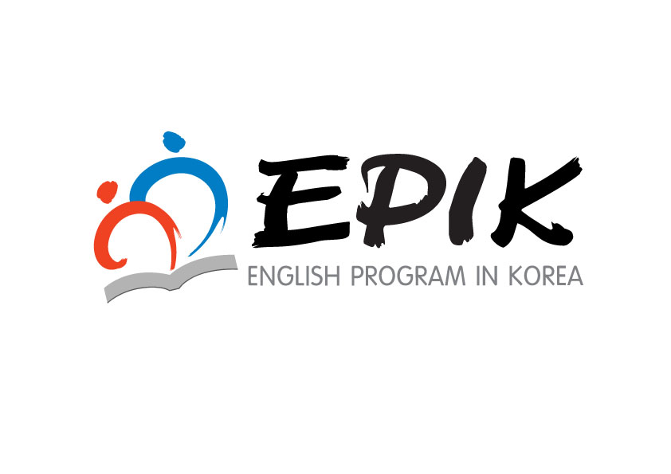

EPIK is holding three video clip contests. The “Co-teaching Video Contest” aims
to showcase the best co-teaching models in order to improve English Education.
The “EPIK Life Video Contest” seeks to improve cultural understanding and to help create
a smooth transition to life in Korea for current and future EPIK teachers.
The “EPIK Volunteer Video Contest” has been established to recognize EPIK teachers who have made
regular, positive contributions to their community and shown good performance in their schools.
We look forward to your interest and participation in these special events.

Eligibility and Award Outline

 | Co-teaching  Video Clip | EPIK Life  Video Clip | EPIK  Volunteer Video Clip
Eligible  Applicants | Korean Teacher &  Guest English Teacher | Guest English Teacher  (GET) | GET who has volunteered for a minimum of  6 months
Topic | Co-teaching Class | School life, daily life in Korea, cultural experiences, etc. | Volunteer experience in your school or community
Awards | ￦1,000,000×1 (Team) | ￦500,000×1 (Individual)
 | ￦800,000×1 (Team) | ￦400,000×1 (Individual)
 | ￦600,000×1 (Team) | ￦300,000×1 (Individual)
 | ￦400,000×1 (Team) | ￦200,000×1 (Individual)

※ Notes
- The number of winners may be adjusted according to the quality of work submitted.
- Winners of the Co-teaching Video Clip will be awarded a prize which is to be shared evenly between both the GET and Korean co-teacher.
- The first-place winners of previous contests and awards cannot participate in the same category.

Contest Schedule
○ Submission Period: Monday, November 9th ~ Monday, November 16th
○ Announcement of Winners: Monday, December 7th
The result will be posted in the “What’s New” section of the EPIK website.
○ EPIK Website Video Upload: Wednesday, December 9th ~ Friday, December 11th
○ Presentation of Awards: Monday, December 7th
○ Transfer of Prize Money: Monday, December 7th ~ Wednesday, December 9th
※ Schedule is subject to change.

Evaluation Criteria

○ Co-teaching Video Clip

 | Criteria | Points
Content | - Is the lesson designed with effective learning activities to assist in achieving the lesson’s goals?  - Do the teachers effectively encourage student participation in the activities?  - Was the lesson effective in increasing the communication competency of the students?  - Does the model class clearly define the roles of the co-teacher and GET?  - Did the teachers provide appropriate and useful teaching materials and use them effectively throughout the lesson? | 50
Usefulness | - Can the model class easily be adapted into a regular classroom?  -Can the entry be used for EPIK training and promotional materials?  - Does the entry support a positive image of EPIK? | 30
Construction and Visual Appeal | - Is each portion of the demonstration edited in a way to help improve understanding of the whole lesson?  - Does the video effectively demonstrate cooperation between teachers and students?  - Is the video clip of good quality and viewer friendly?  - Does the video entertain viewers? | 20

○ EPIK Life/Volunteer Video Clip

 | Criteria | Points
Content | - Does the video contain a variety of activities from all aspects of the GET’s life in Korea? Examples include: school life (teaching  in the classroom, relationship between teachers & students, participation in school events, etc.), cultural experiences, and hobbies in Korea (EPIK Life) or volunteer experience (Volunteer).  - Does the video provide appropriate and useful information to viewers?  - Does the video entertain viewers? | 50
Usefulness | - Can the entry be used for EPIK training and promotional materials?  - Does the entry support a positive image of EPIK? | 20
Construction and Visual Appeal | - Is the video clip well-organized into categories?  - Are the ideas of the entry fresh and creative?  - Is the video clip of good quality and viewer-friendly? | 30

Requirements

` | Requirement Details
Co-teaching  Video Clip | - Application  Attachment 1-1  Attachment 1-2  - 3 copies of Lesson Plan  - 3 copies of “Explanation of Co-teaching”:  KT in Korean & GET in English (2 pages per teacher)  - A CD of Co-teaching Video Clip  ·Type: Movie clip or flash file (WMV, SWF, MP4)  ·Size: Maximum 200 Mega Bytes  ·Running time: 10 minutes  ※ Please edit your class (40~50 minutes) into a 10 minute video clip in a way that best helps viewers understand your lesson.  ※ Previous award winning video clips can be found at www.epik.kr→Co-Teaching Videos  “Explanation of Co-teaching” can be found at Teachers’ Resources→EPIK Teachers’ Essays  /Korean Teachers’ Essays (No. 42)
EPIK Life  Video Clip | - Application  Attachment 2-2  Attachment 2-1  - 3 copies of “ Introduction of Video Clip”  - A CD of EPIK Life Video Clip  ·Type: Movie clip or flash file (WMV, SWF, MP4)  ※ Please submit only video clips and not static photo slide shows.  ·Size: Maximum 100 Mega Bytes  ·Running time: 5 minutes
Volunteering Essay | - Application  Attachment 3-1-1  - Principal’s Recommendation  Attachment 3-1-2  - 3 copies of “ Introduction of Video Clip”(1~2 pages, A4)  Attachment 3-2  - A CD of EPIK Volunteer Video Clip  ·Type: Movie clip or flash file (WMV, SWF, MP4)  ·Size: Maximum 100 Mega Bytes  ·Running time: 5 minutes

How to Apply

○ Submission Period: Monday, November 9th – Monday, November 16th

○ Where to Send Submissions :
▪ Send by mail to: 81 Ihwajang-gil, Jongno-gu, Seoul EPIK Office Room 301
John Hwang (zip code: 03087)
▪ Contact: John Hwang (02-3668-1402, hwangkt3@korea.kr)

IMPORTANT NOTICE
○ The application process requires official document work (Principal’s recommendation & Official Seal, etc.) from your school. You must let your co-teacher, vice principal and principal know your intentions to take part in the contest and clarify what the prize is. We do not accept applicants who do not follow the official application procedures.
○ All movie clips submitted to us will not be returned.
○ If your entry is selected as one of the winners, EPIK will own its copyright and may revise and use it freely for future promotions, orientations and/or training.
○ The winners may have a chance to become lecturers or presenters at an official EPIK orientation.
○ Plagiarism is not allowed. If it is found out at any point, even after receiving an award, that the work submitted was not your own, the award will be revoked and the prize money must be returned to EPIK. The applicant will bear all responsibility for their actions.

Application Form for 2015 Co-teaching Video Clip Contest
Attachment 1-1
접수 번호  (EPIK 기재용) | 2015 EPIK 협력수업 동영상 공모 신청서  Application for 2015 EPIK Co-teaching Video Clip Contest
인적사항  Applicant Information | Name |  | Cell Phone | E-mail
 | (KT)
 | (GET)
학교 및 대상학년 | 학교 (지도대상: 학년)
단원명
근무처 | 우편번호
 | 주소
 | 전화번호 | ( )-( )-( )
입금  계좌 정보  Account Information | Account holder’s Name |  | Bank Name | Account Number
 | (KT)
 | (GET)

본인은 본인의 협력수업 동영상 및 관련 자료가 EPIK 사업과
교육적인 목적으로만 활용되는 것에 동의합니다.
I hereby give permission to use my video clip and other materials
for educational purposes and EPIK related business only.

제출자: 한국인 교사 성명 (인)
Guest English Teacher's Name
Signature

위 교사들은 평상시에도 영어 협력수업을 잘하고 있으며, 본교의 영어교육발전을 위해 늘 헌신하는바, 국립국제교육원 동영상 공모전에 적극 추천합니다.

2015년 11월 일

학교장 성명 (관인)
※ 학교 관인이 있어야 접수 가능함.
Lesson Plan Template
Attachment 1-2

Lesson Plan

▪Title (Unit): (Period: / )
▪School level/Grade:
▪Lesson Focus: Speaking, Listening
▪Objectives:
- Students will be able to
- Students will be able to
▪Key Expressions

▪Materials:

Procedure | Details
Presentation:  Introduction of  Content and Language  (Time: ) | (Example)  GET: Greetings  KT: Introduce the topic using Dingbats followed by a Powerpoint display.  Ss: Guess the expression related to the picture  •Warm-up Activity: Running Dictation with a Korean fairy tale
Practice:  Students begin to work with the language  (Time: ) | •Activity 1: Jigsaw  -Class Arrangement:  GET:  KT  KT & GET:

Procedure | Details
Practice:  Students begin to work with the language  (Time: ) | •Activity 2: Survey
Production:
Students internalize and use the language

(Time: )
Wrap-up
Assessments or other work

(Time: 5)

▪ Anticipated Problems & Solutions
-
-

Application Form for 2015 EPIK Life Video Contest
Attachment 2-1
Application No.  (for office use) | 2015 EPIK Life 동영상 공모 신청서  Application for 2015 EPIK Life Video Clip Contest
Applicant Information | Name |  |  |  | Cell Phone
 | E-mail
School Information | Name  of School
 | Telephone
 | Address  (Write in Korean) | (Zip Code )
Title of
the Video Clip
Account Information | Account Holder’s Name |  | Bank Name | Account Number

I hereby give permission to use my video clip
for educational purposes and EPIK related business only.

Applicant's Name: Signature:

위 사람을 국립국제교육원 EPIK Life 동영상 공모 학교 대표로
적극 추천하는 바입니다.
I strongly recommend the person above
For the NIIED EPIK Life Video Clip Contest as my school's representative.

2015년 11월 일

학교장 성명 (관인)
Name of School Principal's Name Official Seal

- Please obtain an official seal from your school when you apply.

Introduction Form for 2015 EPIK Life Video Clip
Attachment 2-2

Title:
Name: School:
 | Time | Brief Description of Content
Intro
Body
Closing
※ You can adjust the above template.

Application Form for 2015 EPIK Volunteer Video Clip Contest
Attachment 3-1-1

Application No.  (for office use) | 2015 EPIK Volunteer 동영상 공모 신청서  Application for 2015 EPIK Volunteer Video Clip Contest
• Personal Information
Name:
E-mail: |  |  | Cell Phone Number:
Name of School: |  |  | City:
Bank Account Number: |  |  | Bank Name:
• Volunteer Experience in Korea
Dates of Volunteer Service  From - to |  | Average Hours/Week Worked (Total hours) | Briefly describe your volunteer work:
- |  | ( )
- |  | ( )
• Volunteer Organization Information
Name of Organization: |  |  | Phone number:
Website: |  |  | City:
Name of Coordinator: |  |  | E-mail:

I hereby give permission to use my volunteer video clip
for educational purposes and EPIK related business only.

Applicant's Name: Signature: _______________________

Attachment 3-1-2
Recommendation Form for 2015 EPIK Volunteer Video Clip Contest
Recommendation No.  (for office use) |  | 2015 EPIK 자원봉사 동영상 공모 추천서  Recommendation for 2015 EPIK Volunteer Video Clip Contest
Volunteer Information |  | Name |  |  | Cell phone
 |  | E-mail
School Information |  | Name  of School
 |  | Telephone
 |  | Address  (Write in Korean) | (Zip Code )
 |  | Korean Co-teacher | Name
 |  |  | Cell phone

Applicant's Name: Signature:

위 사람은 지역사회 자원봉사활동은 물론,
학교에서의 수업지도에도 성실히 역할수행을 하였기에
국립국제교육원 ‘EPIK 자원봉사 동영상 공모’에 적극 추천하는 바입니다.

I strongly recommend the person above for the NIIED EPIK Volunteer Video Clip Contest because he/she has devoted themselves not only to the community, but also displayed good teaching skills inside the classroom.
2015년 11월 일
학교장 성명 (관인)
Name of School Principal's Name Official Seal

※1. Please fill out the recommendation form and obtain an official seal from your school.
2. Scan and send this file when you apply. The winners will be required to submit the original document at a later date.

Introduction Form for 2015 EPIK Volunteer Video Clip
Attachment 3-2

Title:
Name: School:
 | Time | Brief Description of Content
Intro
Body
Closing

Please share your volunteer experiences.

When sharing your story, the following should be included:
- General information about the organization
- The main duties you performed to help the organization
- The frequency in which you visited and volunteered at the organization
- Challenges faced, if any, during your time volunteering and how you overcame those
obstacles
- Positive or negative effects on your professional life (i.e. regular teaching at your school) as a result from your volunteering activities
- Your future plans, both in volunteering and in Korea

