Greetings from the Northeast Asian History Foundation,

Summer has come around once more with sunny weather. During this beautiful season, you may feel the urge to take a step outside with friends. The two upcoming events by the Northeast Asian History Foundation shall be hosted under the theme ‘Workshop on Current Historical Issues in Northeast Asia.’
The upcoming events should be a great opportunity for fellow native-speaking English teaching assistants working in South Korea to meet, share one another’s “memories and history” and together enjoy the beautiful scenes and traditions Korea has to offer, so we hope many will be interested in participating. Thank you.

- Event 1 -

Do you know who the 'comfort women' of the Japanese military are?
Have you heard of them in the media or from Korean friends around you?
Have you been wondering why Koreans seem so grieved by the term?

For the past twenty years, former comfort women have protested in front of the Japanese embassy in Seoul each and every week, calling upon the Japanese government to redress their issue.

As international society paying more attention to the issue, the Northeast Asian History Foundation plans to visit the home of former comfort women who have suffered their whole lives after having been taken away and forced into sexual slavery by the Japanese military. The event shall be an opportunity to learn about the meaning of the tears former comfort women have been shedding and rethink human dignity and female victims in times of war.

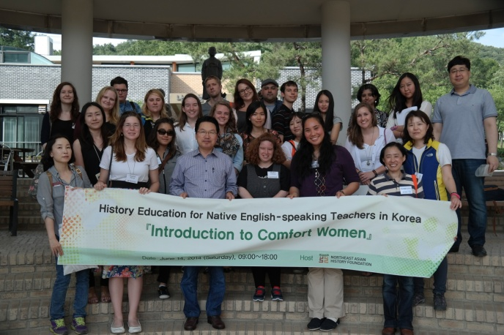
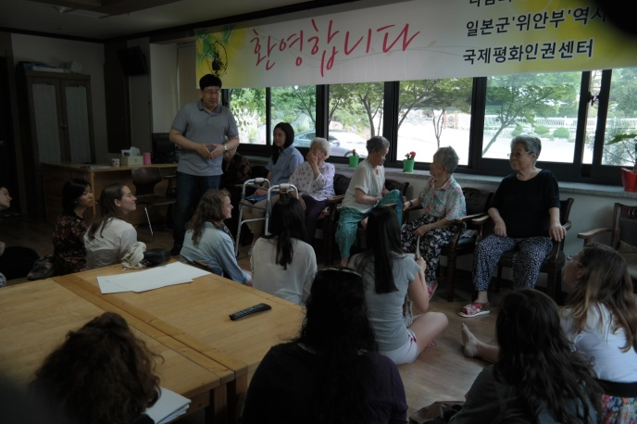

- Event Information -
☞ Event title : Introduction to Comfort Women
☞ Date & Time : July 30, 2015 (Thurs), 09:00~18:00
☞ Host : Northeast Asian History Foundation
☞ Qualifications : Native-speaking English teaching assistants working in South Korea
☞ Destination : House of Sharing at Gwangju, Gyeonggi-do
※ Gather in Seoul and move to destination together (Exact location of gathering to be announced later)
☞ Application Period : June 16 (Tue) ~ July 5 (Sun), 2015
☞ Participation Fee : Free
☞ Application : Download and fill in application form, then submit it via e-mail
(eduhistory@nahf.or.kr)
☞ Selection : First come, first served by order of application
(approximately Thirty applicants shall be selected)
☞ Selection announcement July 8, 2015 (Wed) via text message and e-mail
※ Announcement date may change according to the number of applicants
☞ Itinerary :
Date | Time | Schedule | Location
July 30  (Thurs) | 09:00~09:20 | Check registration & attendance, depart | Seoul  (Exact location TBD)
 | 09:30~10:30 | Travel by bus to Gwangju | Gwangju, Gyeonggi-do
 | 10:30~11:50 | Visit to Korea Ceramic Foundation | Gwangju, Gyeonggi-do
 | 12:00~13:20 | Move to restaurant and have lunch | Restaurant nearby
 | 13:30~16:00 | Attend lecture on comfort women and tour of the history museum of the Japanese military's comfort women | House of Sharing
 | 16:00~18:00 | Travel by bus to Seoul | Seoul
※ The above schedule is subject to change due to unexpected circumstances.
☞ Please send all inquiries to eduhistory@nahf.or.kr

- Event 2 -

Following the visit to the ‘House of Sharing’ in July, you may feel the urge to study more about Korean history and take a step outside as well. Perhaps Seoul may not sound tempting when you think of the busy streets of Myeong-dong or Gangnam. As it turns out, there are many other hidden attractions in Seoul brimming with scenic views and historical stories. How about stepping out on a summer day to follow traces of Korean ancestors and foreigners that came to Seoul about a century earlier than you and savor the summer scenery along one of the four ancient fort walls of Seoul?

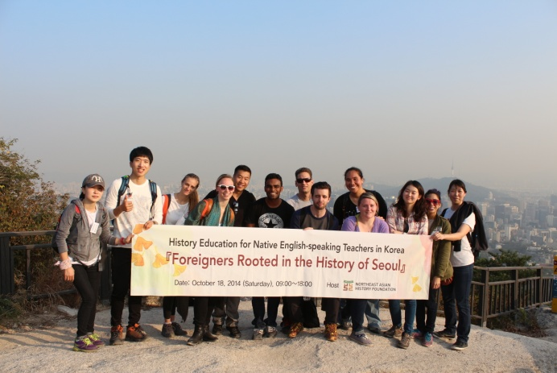
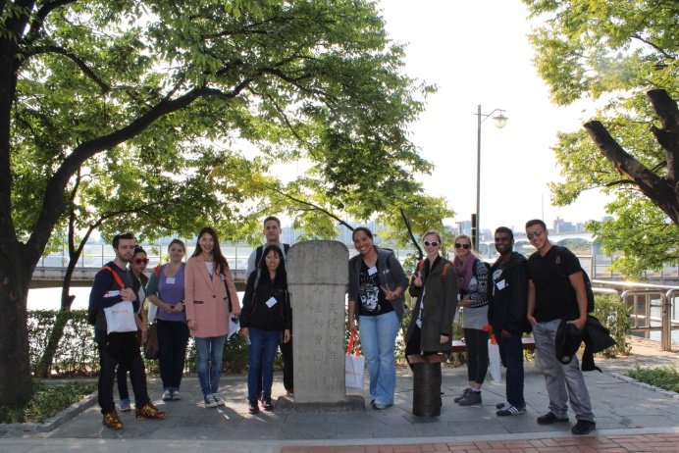

- Event Information -
☞ Event title: Introduction to Dokdo and Seoul a century ago
☞ Date & Time: August 13, 2015 (Thurs), 09:00~18:00
☞ Host: Northeast Asian History Foundation
☞ Qualifications: Native-speaking English teaching assistants working in South Korea
☞ Point of Departure: First floor lobby of the Northeast Asian History Foundation Office (Address: Limgwang Tower West, 267 Migeun-dong, Seodaemun-gu, Seoul)
※ Please refer to the foundation’s website for detailed directions (https://www.nahf.or.kr/eng/)
☞ Application Period : June 16 (Tue) ~ July 5 (Sun), 2015
☞ Participation fee: Free
☞ Application: Download and fill in application form, then submit it via e-mail (eduhistory@nahf.or.kr)
☞ Selection: First come, first served by order of application (approximately thirty applicants shall be selected)
☞ Selection announcement July 8, 2015 (Wed) via text message and e-mail
※ Announcement date is subject to change depending on the number of applicants.
☞ Itinerary
Date | Time | Schedule | Location
August 13  (Thurs) | 09:00~09:20 | Attendance check & Depart | Lobby, Foundation headquarters
 | 09:30~10:30 | Tour of Dokdo Museum Seoul | B1 FL, Limgwang Tower West
 | 10:40~11:00 | Travel by bus | Providing snacks
 | 11:10~12:50 | Seodaemun Prison History Hall | Seoul
 | 13:00~14:30 | Lunch | Nearby restaurant
 | 15:00~17:30 | Walk around Jeong-dong & Seoul City Wall | Inwangsan
 | 17:30~18:00 | Back to Foundation headquarters & Break up | Foundation headquarters
※ The above schedule is subject to change depending on unexpected circumstances.

☞ Note: Exploring the fort wall includes hiking, so please make sure to come along dressed in comfortable pants and sneakers.

